**Contextual inquiry models**

Artifact model: How do you manage you expenses ?

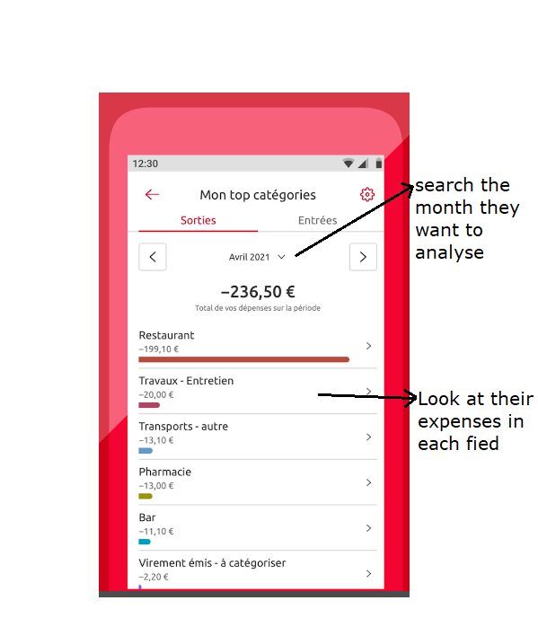

Flow model: How does information flow?

